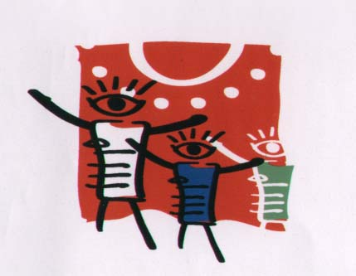

MUSEUM AND ACADEMY
XANTHI HELLAS
10th Biennale 2022- 2024
==-)<>(-=^^

LIFE IN A DROP OF WATER.

The Museum and the Academy of Children's Art organize the 10th BIENNALE of children's art, advocating love, peace, friendship and solidarity, among the peoples of the world.
Through this competition we build bridges of love between the peoples of the world, respecting their uniqueness and tradition.
The theme we chose at the 10th Biennale 2022-2024 is:
LIFE IN A DROP OF WATER.
Most and most important civilizations were created and developed around water. Especially in the Mediterranean, water played an important role in the formation of civilizations. In addition, the reference to water in Greek mythology is very large and several rivers were presented as Gods. The ocean was the huge river that flows around the Earth, without estuaries and springs. Acheloos was the most majestic of the river-sons of the Ocean and had the ability to transform sometimes into a dragon and sometimes into a bull. The water was connected several times and not with fear. That is why the sea and the fierce river led the people to glorify the gods, in order to face their fears.
The roads through the rivers and the sea provided human societies not only with water for their crops and food, but also with a safe and easy route for movement, trade, product exchanges, and human-to-human communication. Peoples and cultures.
Egyptian culture connected its life with the river Nile, the culture of Mesopotamia with the Tigris and the Euphrates, in Latin America we have the great lung of the earth the Amazon and the Greek culture developed on the rich shores of the Aegean and the Mediterranean. The element of water is dominant in Greek mythology The flood of water is also very often described in world psychology as well as the glaciers that also capture the great history of mankind.
For Biennale, paint unique images of your homeland through your own culture, mythology, fairy tales and water-related history. The value of water is very high for humans. Let us seek to find its magic and show respect for water, its history and therefore the evolution of humanity.
We wish teachers and students good inspiration and hope the children understand the value of even a drop of water in our lives.
We look forward to accept your creations and we wish you
GOOD LUCK !!!
TERMS OF ENTRY
All children from 4 to 17 years of age may enter by sending a small piece of their souls and thoughts. Original works of art only! No copies or grown up interventions on the children’s work are allowed. Their pictures are going to fill us with joy as they represent the children themselves.
Most information www.oikoumeni.gr
Dimensions and techniques
The works to be shipped must be painted on canvas or paper measuring 45X45 or 40X 60cm.

The prizes !!!!!!!!
The prizes will be sent electronically so please send us your Email written electronically with the font Times New Roman, so that you will not be mistaken or send us your participation in the
E-mail: litamavrogeni@gmail.com

Please take photographs or videos showing the children while at work. These can be projected during the exhibitions. Write all the information we ask for you with capital letters.
The last day of dispatch is 30 May 2022
Mail to: President
Ms.Mavrogeni Lita
MUSEUM AND ACADEMY
CHILDREN'S ART
Ipiatrou Triantafillidi, Nο 26, P.K 67100
Xanthi HELLAS

Tel 0030 25415 52228
E-mail: litamavrogeni@gmail.com

Please photocopy the table below separately for each participant and attach it on the back side of the children’s works after you fill in all the information in clearly written capital letters.
………………………………………………………………………………………
Individual Participation  First Name: |  |  |  | Sex |  | Date of birth
 |  |  |  | F | M
Surname: |  |  |  | Age
Country:  E-mail: | Use zip codes  TEL:……………………………………  FAX:………………………………………
Home address/Town/Prefecture or county |  |  | School grade………….  Address of school/ workshop/association etc
Name of teacher or workshop/association |  |  | City:  Prefecture/County
Date of completion of the work
Work Title |  |  | 10th BIENNALE 2022  Xanthi-Thrace-Greece  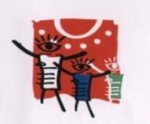
Work Title

