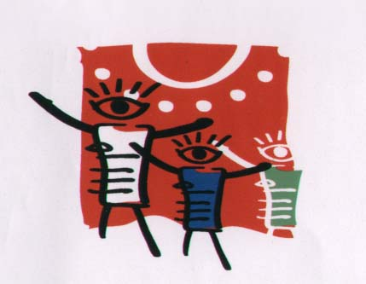

MUSEUM AND ACADEMY
XANTHI HELLAS
9th Biennale 2020-2021
THE NEIGHBORS OF THE WORLD
==-)<>(-=^^

The Museum and Children's Art Academy are organizing the 9th BIENNALE Children's Art, promoting love, peace, friendship and solidarity among the peoples of the world.
Through this competition we build bridges of love among the peoples of the world, respecting their particularity and tradition.

The theme we chose at the 9th Biennale 2020-2021 is:
THE NEIGHBORS OF THE WORLD
Our neighborhood is a refuge of love, solidarity, forgiveness, judgment, acceptance and rejection.
It is always the most beautiful memory of our childhood.
The unity of people living in the neighborhood teach us the great values ​​of life. The families in the neighborhood are the families we share with them the joy, the sadness of our dreams.
They are the spectators but they can also be the protagonists in our own scene in our own roles.
It is the largest school of society, it is society itself that teaches us how to play and enjoy life mildly.
In modern times with big urban centers the value and beauty of the old neighborhood has been lost a new way of life has changed things, but the neighborhood is always in our hearts a little further away from the past but there has always been a great need for man to grow up with other children and share life's moments.
Paint the picture of your neighborhood, with its beauty and love for what it is, its homes, its streets, its friends, its people, its shops, its cafes.
We want to see pictures of games with friends in your neighborhood.
We look forward to your work from the neighborhoods of the world.
We look forward to accept your creations and we wish you
GOOD LUCK !!!
TERMS OF ENTRY
All children from 4 to 17 years of age may enter by sending a small piece of their souls and thoughts. Original works of art only! No copies or grown up interventions on the children’s work are allowed. Their pictures are going to fill us with joy as they represent the children themselves.
Most information www.oikoumeni.gr
Dimensions and techniques
The works to be shipped must be painted on canvas or paper measuring 45X45 or 40X 60cm.

The prizes !!!!!!!!
The prizes will be sent electronically so please send us your Email written electronically with the font Times New Roman, so that you will not be mistaken or send us your participation in the
E-mail: litamavrogeni@gmail.com

Please take photographs or videos showing the children while at work. These can be projected during the exhibitions. Write all the information we ask for you with capital letters.
The last day of dispatch is 30 May 2020
Mail to: President
Ms.Mavrogeni Lita
MUSEUM AND ACADEMY
CHILDREN'S ART
Ipiatrou Triantafillidi, Nο 26, P.K 67100
Xanthi HELLAS

Tel 0030 25415 52228
E-mail: litamavrogeni@gmail.com

Please photocopy the table below separately for each participant and attach it on the back side of the children’s works after you fill in all the information in clearly written capital letters.
………………………………………………………………………………………
Individual Participation  First Name: |  |  |  | Sex |  | Date of birth
 |  |  |  | F | M
Surname: |  |  |  | Age
Country:  E-mail: | Use zip codes  TEL:……………………………………  FAX:………………………………………
Home address/Town/Prefecture or county |  |  | School grade………….  Address of school/ workshop/association etc
Name of teacher or workshop/association |  |  | City:  Prefecture/County
Date of completion of the work
Work Title |  |  | 9th BIENNALE 2020  Xanthi-Thrace-Greece  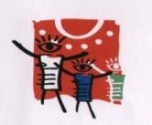
Work Title

